**PRACTICAL NO: 5**

**CODE:**

**DATABSE AND TABLE CREATION:**

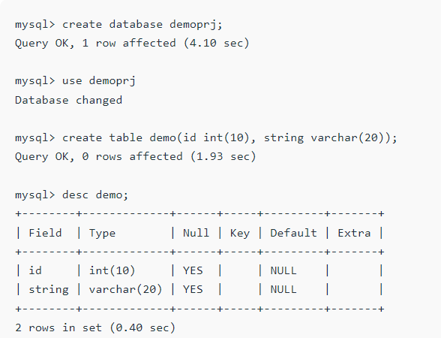

2] CREATE HTML FORM:

<!DOCTYPE html>

<html>

<head>

<title>Insert Data</title>

</head>

<body>

<!-- Give Servlet reference to the form as an instances

GET and POST services can be according to the problem statement-->

<form action="./InsertData" method="post">

<p>ID:</p>

<!-- Create an element with mandatory name attribute,

so that data can be transfer to the servlet using getParameter() -->

<input type="text" name="id"/>

<br/>

<p>String:</p>

<input type="text" name="string"/>

<br/><br/><br/>

<input type="submit"/>

</form>

</body>

</html>

**OUTPUT:**

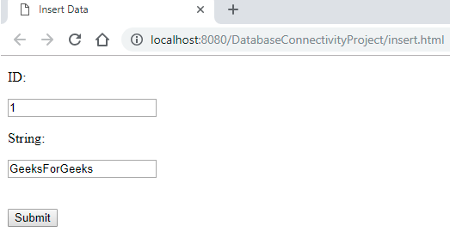

**CREATE JAVA SERVLET CONNECTION WITH MYSQL:**

import java.sql.Connection;

import java.sql.DriverManager;

import java.sql.SQLException;

// This class can be used to initialize the database connection

public class DatabaseConnection {

protected static Connection initializeDatabase()

throws SQLException, ClassNotFoundException

{

// Initialize all the information regarding

// Database Connection

String dbDriver = "com.mysql.jdbc.Driver";

String dbURL = "jdbc:mysql:// localhost:3306/";

// Database name to access

String dbName = "demoprj";

String dbUsername = "root";

String dbPassword = "root";

Class.forName(dbDriver);

Connection con = DriverManager.getConnection(dbURL + dbName,

dbUsername,

dbPassword);

return con;

}

}

**JAVA SERVLET:**

import java.io.IOException;

import java.io.PrintWriter;

import java.sql.Connection;

import java.sql.PreparedStatement;

import javax.servlet.ServletException;

import javax.servlet.annotation.WebServlet;

import javax.servlet.http.HttpServlet;

import javax.servlet.http.HttpServletRequest;

import javax.servlet.http.HttpServletResponse;

// Import Database Connection Class file

import code.DatabaseConnection;

// Servlet Name

@WebServlet("/InsertData")

public class InsertData extends HttpServlet {

private static final long serialVersionUID = 1L;

protected void doPost(HttpServletRequest request,

HttpServletResponse response)

throws ServletException, IOException

{

try {

// Initialize the database

Connection con = DatabaseConnection.initializeDatabase();

// Create a SQL query to insert data into demo table

// demo table consists of two columns, so two '?' is used

PreparedStatement st = con

.prepareStatement("insert into demo values(?, ?)");

// For the first parameter,

// get the data using request object

// sets the data to st pointer

st.setInt(1, Integer.valueOf(request.getParameter("id")));

// Same for second parameter

st.setString(2, request.getParameter("string"));

// Execute the insert command using executeUpdate()

// to make changes in database

st.executeUpdate();

// Close all the connections

st.close();

con.close();

// Get a writer pointer

// to display the successful result

PrintWriter out = response.getWriter();

out.println("<html><body><b>Successfully Inserted"

+ "</b></body></html>");

}

catch (Exception e) {

e.printStackTrace();

}

}

}

**OUTPUT**:

